Chapter 6
The Little Man Computer

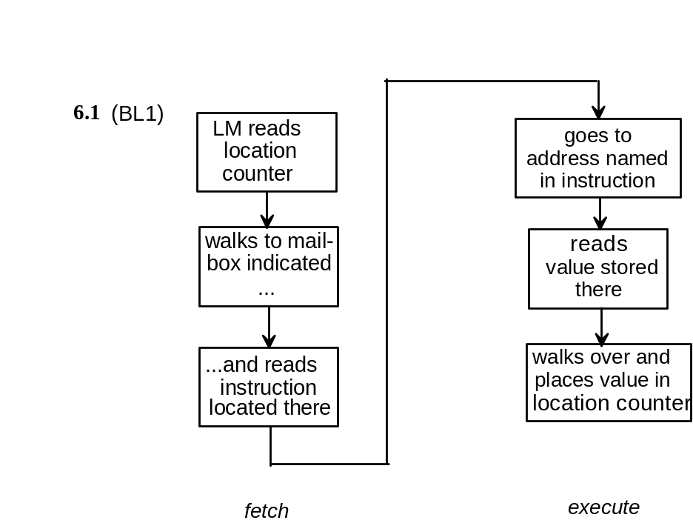
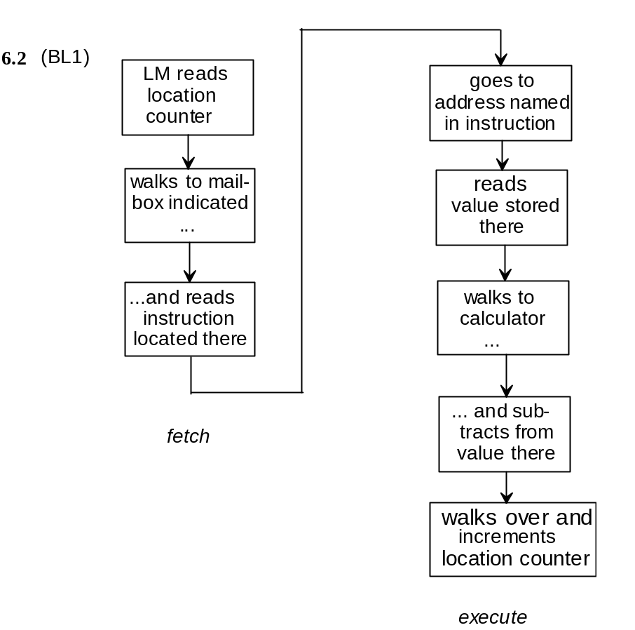

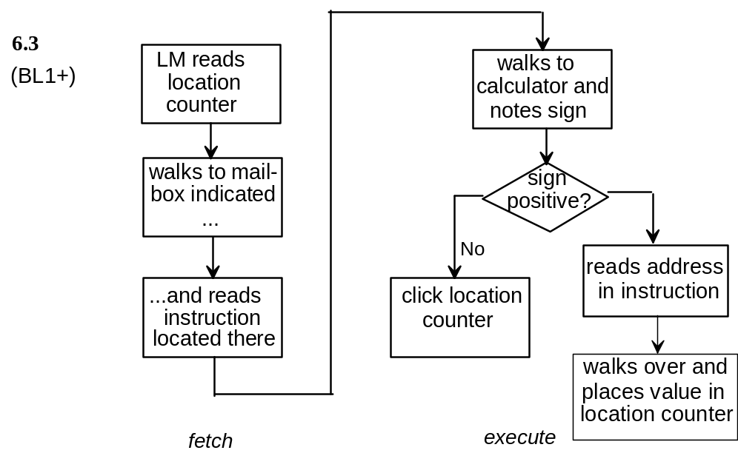

6.4 (BL1) A von Neumann architecture is defined by the “stored program concept,” which has the following characteristics (the connections are obvious!):

1. Program stored and executed from memory
2. Program code and data stored in memory, and identified by context when used
3. Program instructions executed sequentially, unless modified by the execution of an instruction that changes the program flow. von Neumann described the use of a program counter register to control the flow.

von Neumann also described a specific CPU design made up of a control unit and an arithmetic logic unit. Some authors consider these to be part of the von Neumann architecture that forms the basis for nearly all modern computing, however these features are not critical to the stored program concept. Most modern designs use a somewhat different organization (discussed in Chapters 10 and 12), although the ALU/CU model is certainly valid as an abstract concept, and is used as a basis for Chapter 7.

6.5 (BL1+) If the first entry were stored in mailbox 00, it would not affect the result during the first execution of the program, however, if the program is run again, it will attempt to execute the data that is now stored at location 00 as if it were an instruction. The program would work only if the data happened to be 901. This situation illustrates the concept that the CPU only distinguishes between program instruction and data in the context of what it expects to find.

6.6 (BL2-BL2+) This problem addresses a number of student issues—

- It shows how simple instructions are combined to solve complex problems.

- It addresses the issue of separating algorithms from coding. Many students will attempt to code the solution without considering the algorithm first.

- It shows how even simple problems require a large number of instructions.

- It shows how many instructions are required just to move data around to get the data into the place it's required at any given time.

There are obviously a number of different solutions to this problem. Some students solve the problem by brute force : they subtract every pair of values to find the largest. The method shown here is one step below that. It inputs and saves all three numbers. Then it compares the last two. (This saves a LOAD, since the third number is already in the calculator.) The larger of the two is then placed into the calculator, and compared against the remaining input value. This is the type of solution that most of my students come up with. A more general approach is shown in Problem 6.7.

00 INP 901 ;input three numbers and save
01 STO 99 399
02 INP 901
03 STO 98 398
04 INP 901
05 STO 97 397
06 SUB 98 298 ;subtract number in 98 from that in 97
07 BRP 10 811 ;number in 97 larger
08 LDA 98 598 ;number in 98 larger-restore 98
09 BR 11 611
10 LDA 97 597 ;restore 97
11 STO 96 396 ;store larger of (97, 98) in 96
12 SUB 99 299 ;subtract number in 99 from larger
13 BRP 16 816 ;number in 96 larger
14 LDA 99 599 ;number in 99 larger--restore 99
15 BR 17 617
16 LDA 96 596 ;restore 96
17 OUT 902
18 COB 000

A common error encountered when this approach is used occurs around instruction 11. Students would like to subtract the third number from the higher of the previous two, rather than treat each case separately, so they reload the highest number in the calculator without saving it. If the third number is smaller, they are then stuck, because the previous high value is no longer available. They can solve this problem either by saving the previous high value, or by adding the third value back.

6.7 (BL3-) This problem forces students to consider a more general approach. The simplest approach is to create a location for the highest number and load the first number into it. Each following number is read in, stored (in case it's needed), and compared. The higher number is stored, and the process continued until the 00 flag is encountered.

00 INP 901
01 STO 99 399 ;store the first number in 99
02 INP 901
03 BRZ 11 711 ;completion flag
04 STO 98 398 ;store new value temporarily
05 SUB 99 299
06 BRP 08 808 ;new value larger--replace
07 BR 02 602 ;old value larger--get next number
08 LDA 98 598
09 STO 99 399
10 BR 02 602
11 LDA 99 599
12 OUT 902
13 COB 000

6.8 (BL3) This problem is best offered as a challenge to students with strong programming skills. It requires careful analysis, and takes lots of steps regardless of the approach. Here's one solution. It puts the first two values in order first, then compares the third value against each.

00 INP 901
01 STO 99 399
02 INP 901
03 STO 98 398
04 SUB 99 299
05 BRP 12 812 ;numbers are in order (98, 99)
06 LDA 99 599 ;swap 98 and 99
07 STO 96 396 ;a common error is to forget to save the...
08 LDA 98 598 ;...first number in the swap
09 STO 99 399
10 LDA 96 596
11 STO 98 398
12 INP 901 ;input third number
13 STO 97 397
14 SUB 98 298
15 BRP 30 830 ;numbers are in order (97, 98, 99)
16 LDA 97 597 ;swap 97 and 98
17 STO 96 396 ;note: a trick--swapping this way leaves 98 in A...
18 LDA 98 598 ;...ready for next operation
19 STO 97 397
20 LDA 96 596
21 STO 98 398
22 SUB 99 296 ;compare 98 and 99
23 BRP 30 830 ;(98, 99) are in correct order
24 LDA 98 598 ;swap 98 and 99
25 STO 96 396
26 LDA 99 599
27 STO 98 398
28 LDA 96 596
29 STO 99 399
30 LDA 97 597 ;output results
31 OUT 902
32 LDA 98 598
33 OUT 902
34 LDA 99 599
35 OUT 902
36 COB 000

Most students will come up with solutions ranging from 40 to 70 instructions. I sometimes offer a prize (coffee and donuts) to the student coming up with the shortest solution.

6.9 (BL2+) The trick here is in counting the number of times through the loop correctly. With only one accumulator, the sum must be saved each time before the index can be manipulated. The student will need to figure out that the values “0” and “1” must be placed somewhere as constants to be used. The sum must be initialized to “0”, or the value will be incorrect if the program is rerun!

00 LDA 90 590
01 STO 99 399 ;initialize sum to zero
02 INP 901 ;input the count..
03 STO 98 399 ;..and save it in 98
04 INP 901 ;input a number
05 ADD 99 199
06 STO 99 399 ;add to sum and store sum
07 LDA 98 598
08 SUB 91 291 ;decrement count by 1
09 BRZ 11 711 ;done--output result
10 BR 04 704 ;not done--ready for next input
11 LDA 99 599
12 OUT 902 ;output result
13 COB
90 DAT 00 000 ;constant value 0
91 DAT 01 001 ;constant value 1

6.10 (BL3-) The major issue here is writing the program so that it stops at 99, and restoring the value each time after checking the count. The problem can be solved either by counting the number of outputs or by comparing the value to 99. The solution below takes the latter approach.

00 LDA 09 509 ;load the value 1
01 OUT 902 ;output a value
02 ADD 10 110 ;add 2
03 STO 12 312 ;store temporarily
04 SUB 11 211 ;subtract 100
05 BRP 08 808 ;done
06 LDA 12 512 ;restore value
07 BR 01 601
08 COB 000
09 DAT 01 001 ;constant value 1
10 DAT 02 002 ;constant value 2
11 DAT 100 100 ;constant value 100

6.11 (BL3) This program outputs the squares of consecutive integers ranging from 1 to 20

00 LDA 91 591
01 STO 98 398 ;initialize index (98) with the value 1
02 STO 99 398 ;also set the initial sum (99) to 1
03 OUT 902 ;output current sum
04 LDA 98 598
05 ADD 92 192 ;increment the index by 2
06 STO 98 398
07 SUB 93 293 ;subtract the value 40
08 BRP 13 813 ;done
09 LDA 99 599 ;load current sum
10 ADD 98 198 ;add new index..
11 STO 99 399 ;..and save new sum
12 BR 03 603 ;continue looping
13 COB 000
91 DAT 01 001 ;constant value 1
92 DAT 02 002 ;constant value 2
93 DAT 40 040 ;constant value 40

6.12 (BL2-) The program actually outputs IN3 - (IN1 + IN2), the negative of the desired result. To fix it, we have to write the program to subtract the other way. Only the changes are shown:

06 STO 98 398 ;store IN3
07 LDA 99 599 ;recall IN1 + IN2
08 SUB 98 298 ;subtract IN3
09 OUT 902
10 COB 000

6.13 (BL2+) (This problem is appropriate only if Chapter 5 has been covered.)

a. In this case, subtraction would be performed by complementing the value to be subtracted, and would then add to get the result.

b. There are a number of ways the Little Man could perform complementation. He could subtract the value from 1000 in his head and use that value. (He can't use the calculator for this purpose unless a fourth digit is made available.) Alternatively, he could load 999 into the calculator, subtract the value to be complemented, and then add 1 to the result. In either case, he uses only three digits if there is an overflow into the fourth place. Both methods are viable for real computers.

c. The new range of values available is -500 to +499, and the values are represented in 10s complement form.

d. To execute a BRP, the Little Man would check to see if the value starts with 0, 1, 2, 3, or 4. If it does, he takes the branch to the address specified.

6.14 (BL3) This program uses the ability to treat instructions as data to modify a STORE instruction for indexing purposes. Location 00 contains 987, a jump to location 87. The following code will load a program from the in basket into consecutive mailboxes starting at location 01, and then jump to 01 to execute the program. (Note that repeat execution of the same program requires starting at location 01 instead of location 00.)

86 LDA 98 598 ;initialize the STORE instruction at loc. 92
87 STO 92 392
88 INP 902 ;input a value
89 SUB 97 297 ;subtract 999
90 BRZ 01 701 ;done loading--jump to 01 for execution
91 ADD 97 197 ;restore input value
92 DAT 00 000 ;store value. This will contain 3XX, with XX indexed ;each time (see 87-88 and 93-95)
93 LDA 92 592 ;load the STORE instruction in 92
94 ADD 99 199 ;increment it
95 STO 92 392 ;and resave it
96 BR 88 688 ;continue with the next input
97 DAT 999 999 ;value 999 for testing
98 DAT 301 301 ;initial STORE 01 instruction as a data value
99 DAT 01 001 ;value 1 for indexing

6.15 (BL2+) An IF-THEN-ELSE would be implemented by putting the test condition into a form that can be used with a SKIP instruction. For example:

LL caclulate test condition value
where result is positive or 0 for TRUE, negative for FALSE
...
MM BRP NN ;jump if condition is TRUE
MM+1 program code for FALSE condition

...
JMP PP /jump around TRUE condition program code
NN TRUE condition program code
...
PP program code following IF-THE-ELSE

6.16. (BL2+) As in 6.15, it is necessary to calculate a condition code that can use the branch instructions.

MM program code to be repeated
....
program code to calculate test condition result
say, positive or 0 for TRUE, negative for FALSE
....
BRP PP
BR MM /FALSE, repeat the program code
PP program code following REPEAT-UNTIL

6.17 (BL2) If the input data occurs in the wrong order, it is simply input in the order it occurs, and saved in memory until it is needed.

6.18 (BL2) Four bits would be required to implement the op codes of the 10 instructions. Obviously this means that we could add another six instructions to the instruction set. The remaining 12 bits would be used for addresses. Therefore, the machine could accommodate 2¹², or 4096 mailboxes. Sixteen bits of data can accommodate 2's complement numbers in the range -32768 ≤ number ≤ 32767.

6.19 (BL2) If a programmer forgets to put a COB instruction at the end of their program, the program can continue on into the data, and attempt to execute the data as though they were program instructions. It is far more likely that the mailboxes following the program would contain 0 than that they would contain 700. Unused mailboxes would often contain 0. Thus, it is far more likely that the program will stop, rather than run away.

6.20 (BL2+) Suppose the branch is located at mailbox 23. Then the following sequence will do the job:

23 BRP 25
24 BR 50

6.21 (BL2+) Suppose the branch is located at mailbox 23. Then the following sequence will work:

23 BRZ 25
24 BRP 75

